
Chapel St Leonards Primary School
Maths

Intent
- Empowerment through Mastery: We cultivate confident mathematicians who embrace challenges with a ‘can do’ attitude. Our carefully sequenced, small-step approach ensures that foundational knowledge is securely consolidated before new concepts are introduced.
- Building Essential Life Skills: Guided by our Skills Builder Universal Framework, our curriculum nurtures key competencies—listening, speaking, problem solving, creativity, positivity, ambition, and leadership—that prepare pupils for real-world challenges.
- Social Justice & Future Success: We believe that mathematics is a powerful tool for social justice and a critical asset in the world of work, ensuring that every pupil not only learns maths but sees its relevance in everyday life.
- Deep and Systematic Understanding: Our aim is to develop pupils’ fluency, reasoning, and problem-solving skills through a balanced mix of concrete, pictorial, and abstract experiences.
Implementation
- Mastery Approach: Lessons are structured around the White Rose curriculum, supported by NCETM materials, and built on the core principles of mastery:
  - Coherence: Lessons are divided into small, connected steps that build on prior learning.
  - Representation and Structure: Multiple representations are used to reveal the underlying mathematical concepts.
  - Mathematical Thinking: Pupils engage in discussions, reason through ideas, and explore concepts collaboratively.
  - Fluency: Regular, low-stakes practice helps ensure that facts and procedures are recalled quickly and accurately.
  - Variation: Concepts are presented in diverse ways to deepen understanding and encourage flexibility in problem solving.

- Integrated Learning: Our daily Maths lessons are enriched with resources such as Times Table Rockstars and NumBots, making learning engaging, challenging, and directly connected to real-world contexts.
Impact
- Progress and Confidence: Through continuous formative assessments and responsive feedback, we ensure that any gaps in learning are promptly addressed, allowing every child to progress steadily and confidently.
- Fluency and Deep Understanding: Our systematic approach not only builds numerical fluency but also deepens pupils’ conceptual understanding, enabling them to communicate their mathematical reasoning with clarity.
- Skills for Life: Beyond academic success, our curriculum equips pupils with critical thinking and problem-solving skills that are essential for lifelong learning and future career success.
At Chapel St Leonards Primary, Mathematics is more than just a subject—it is a vital tool for understanding the world. Our approach aligns with the latest research and best practices in mathematics education, ensuring that every lesson builds a robust, lasting foundation for our pupils’ future.

Research and Rationale
At Chapel St Leonards Primary School, we implement White Rose Maths across all year groups, including mixed-age classes. Our approach is informed by educational research, including Rosenshine’s Principles of Instruction, cognitive load theory, and evidence-based mastery strategies. These principles advocate for daily review, small-step instruction, guided practice, and scaffolded learning—all of which underpin the White Rose scheme. The programme is designed to develop fluency, reasoning, and problem-solving through a consistent, structured approach that supports all learners.

Planning and Progression in Mixed-Age Classes
We follow White Rose's mixed-age planning sequences for Years 1/2, 3/4, and 5/6. These plans align key concepts across both year groups, allowing teachers to teach a shared topic (e.g., place value or fractions) while adjusting the depth and complexity of tasks. Each year group accesses content suited to their curriculum expectations while benefitting from the shared mathematical focus. Long-term and weekly planning is adapted to ensure coverage, progression, and retrieval opportunities.

What a White Rose Maths Lesson Looks Like
Lessons typically begin with a retrieval activity such as 'Flashback 4' to reinforce prior learning. The teacher then presents a shared ‘Discover and Share’ input, modelling the concept using concrete and pictorial representations. Pupils then move to year-group specific ‘Think Together’ activities with adult support, followed by independent practice. Lessons follow the CPA (Concrete, Pictorial, Abstract) approach to embed conceptual understanding.

How Adults Support Learning
Teaching Assistants play a crucial role in supporting learning within mixed-age classrooms. Typically, the class teacher begins by guiding the younger year group while the TA supports the older group. After a set time, the adults switch roles. This flexible model ensures that both year groups receive guided teaching during the lesson. TAs also provide targeted support during independent work and small group interventions.

What is Achieved
Through the White Rose approach, pupils build fluency, develop mathematical reasoning, and become confident problem-solvers. The consistent structure, use of visual models, and small-step progression support pupils of all abilities. Mixed-age planning also enables peer support, vocabulary development, and curriculum cohesion. Formative assessment is built into each lesson, allowing staff to identify misconceptions and plan next steps.

Supporting Mixed-Age Learning
White Rose Maths ensures that lessons build upon each other across age groups. For example, while both Year 3 and 4 might be learning about fractions, Year 3 may focus on unit fractions while Year 4 deepens this with equivalent fractions and reasoning. Lessons are structured to provide shared learning experiences while differentiating appropriately, creating coherence and challenge across the class. Teachers also use flashbacks and review tasks to revisit previous learning and ensure retention over time.

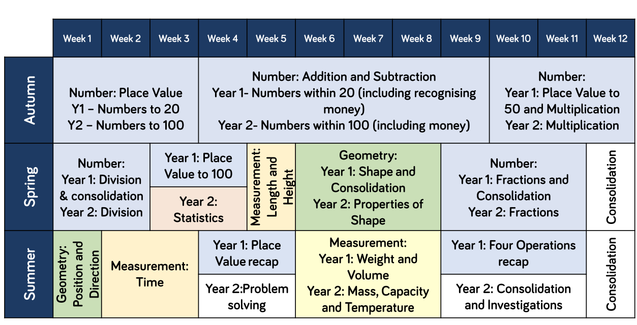
Y1/2 Long Term Plan

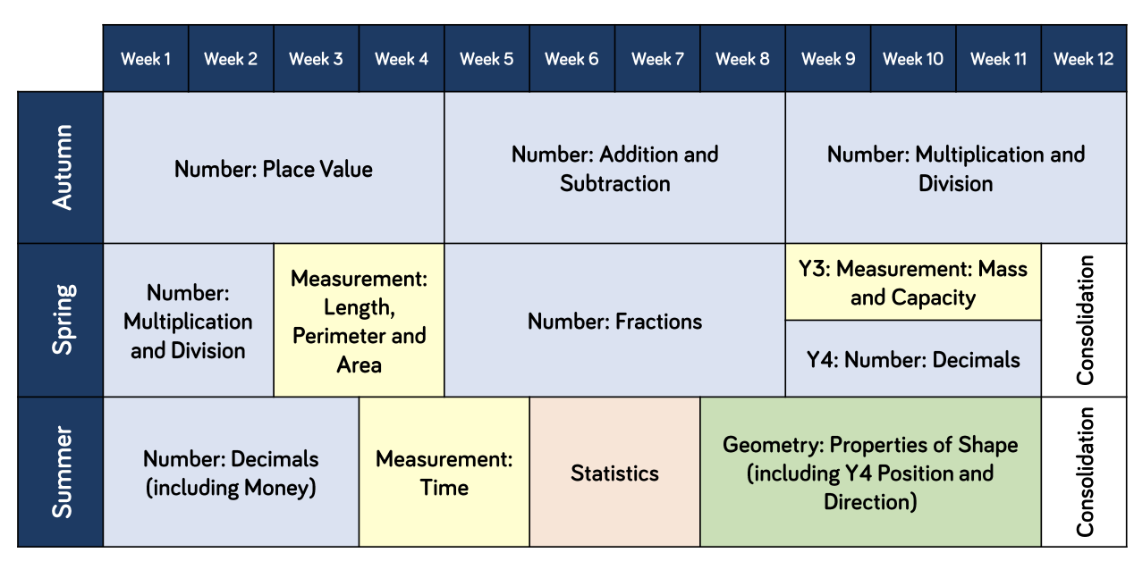
Y3/4 Long Term Plan

Y5/6 Long Term Plan
