British Values
• Explore democracy, rights and respect through assemblies.
• Discuss equality and justice through humanities and RE.
• Participate in class charity projects and Young Governor elections.
• Embrace the 5 Mission Possibles daily in school life.
British Values (cont.)
• Develop greater awareness of protected characteristics.
• Visit Parliament and take part in mock trials at local courts.
• Engage in RUDE and Pupil Leadership workshops.
• Learn about civic responsibility through residential and enrichment experiences.
🌈 Being a Respectful Citizen
• Recognise how social media can influence opinions.
• Celebrate and respect differences in culture, religion, and gender.
• Reflect on prejudice-based bullying and stereotypes.
• Understand bystander behaviour and challenge discrimination.
• Participate in EARA group and community awareness activities.
🛡️ Keeping Safe
• Learn about legal and illegal drugs, norms and risks.
• Understand emotional needs and peer influence.
• Stay safe using mobile technologies and social media.
• Engage in NSPCC and anti-knife crime workshops.
• Develop responsibility on school trips and theme park visits.
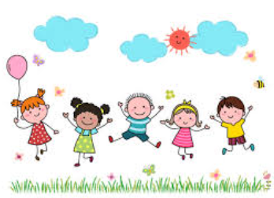

🤝 Anti-Bullying & Friendships
• Recognise and reflect on prejudice-based bullying.
• Understand bystander behaviour and gender stereotyping.
• Engage in residential visits to develop independence and teamwork.
• Take part in Anti-Bullying Week and NSPCC workshops.
• Prepare for Y6 secondary transition and support EYFS buddies
💻 E-Safety
• Explore self-image, online relationships, and reputation.
• Understand risks of online bullying and misinformation.
• Learn about copyright, ownership and online safety laws.
• Engage with Safer Internet Day and Cyber Ambassador initiatives.
🍎 Health & Wellbeing
• Manage change and cope with emotional challenges.
• Develop body image and self-esteem.
• Learn about healthy habits, food and exercise.
• Explore financial wellbeing and responsible decision making.
• Participate in mindfulness and goal setting sessions.
💬 Relationships
• Learn about positive and respectful relationships.
• Develop assertiveness and friendship skills.
• Understand safe and unsafe touches.
• Explore emotional needs and managing compromise.
🔥☀️💧 Fire / Sun / Water Safety
• Take part in sailing and water safety sessions RNLI.
• Understand life-saving techniques and beach safety.
• Engage in RNLI visits for water-based learning.
Corals
Safeguarding

