💬 Relationships
• Learn to accept others’ opinions respectfully.
• Develop understanding of marriage and commitment.
• Recognise body language and how to express emotions assertively.
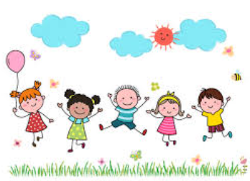

🌈 Being a Respectful Citizen
• Show respect for community groups and diversity.
• Celebrate faiths, religions and cultural differences through RE and Geography.
• Identify examples of tolerance and challenge stereotypes.
• Discuss fairness and equality in assemblies and PSHE.
🚸 Road Safety
• Understand road awareness and driver responsibility.
• Learn about road traffic incidents and safe pedestrian behaviour.
• Engage with PCSO, focusing on community safety
🤝 Anti-Bullying & Friendships
• Revise that bullying is ‘several times on purpose’ and should be reported.
• Learn about different types of bullying.
• Engage in residential visits – developing independence and coping strategies.
• Take part in Anti-Bullying Week activities and NSPCC workshops.
🍎 Health & Wellbeing
• Understand physical and emotional health responsibilities.
• Learn about puberty and changing bodies.
• Take part in 2 hours of PE weekly with a specialist.
• Engage in mindfulness, goal setting and healthy snack activities.
• Explore financial wellbeing and money sense topics.
British Values
• Participate in assemblies exploring democracy and respect.
• Recognise Mission Possibles in daily learning.
• Discuss equality and fairness through history and RE.
• Take part in class charity projects and Young Governor elections.
🔥💧☀️ Fire / Water / Sun Safety
• 10-week swimming programme .
• Y3/4 residential activities involving water safety awareness.
• Learn the Firework Code and sun protection messages.
🛡️ Keeping Safe
• Identify people or things that may influence risky choices.
• Learn about the effects of smoking, alcohol and drugs.
• Discuss how to make safe choices and resist peer pressure.
• Engage with school nurse and outdoor residential safety sessions.
💻 E-Safety
• Understand self-image, identity and online reputation.
• Learn about safe online relationships and communication.
• Explore the risks of online bullying and misinformation.
• Engage in Safer Internet Day and anti-cyberbullying campaigns.
Jellyfish
Safeguarding

